LENGTH = 5, 7 , 9 , 10

K = 7, 5, 70 , 121

ALL case

#5

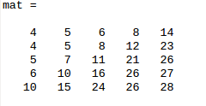

Ans :

(2, 1 )

#7

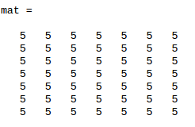

Ans :

(0, 0 ) (1, 0 ) (2, 0 ) (3, 0 ) (4, 0 ) (5, 0 ) (6, 0 )

(0, 1 ) (1, 1 ) (2, 1 ) (3, 1 ) (4, 1 ) (5, 1 ) (6, 1 )

(0, 2 ) (1, 2 ) (2, 2 ) (3, 2 ) (4, 2 ) (5, 2 ) (6, 2 )

(0, 3 ) (1, 3 ) (2, 3 ) (3, 3 ) (4, 3 ) (5, 3 ) (6, 3 )

(0, 4 ) (1, 4 ) (2, 4 ) (3, 4 ) (4, 4 ) (5, 4 ) (6, 4 )

(0, 5 ) (1, 5 ) (2, 5 ) (3, 5 ) (4, 5 ) (5, 5 ) (6, 5 )

(0, 6 ) (1, 6 ) (2, 6 ) (3, 6 ) (4, 6 ) (5, 6 ) (6, 6 )

#9

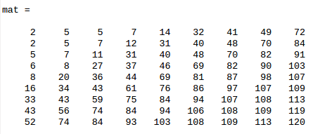

Ans :

(2, 6 ) (1, 7 )

#10

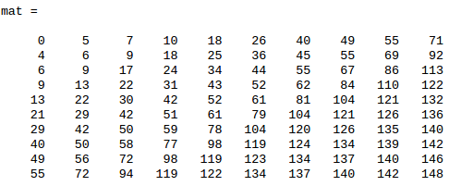

Ans :

(5, 7 ) (4, 8 )

Single K case

#5

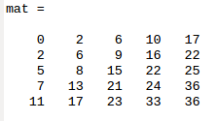

Ans :

(3, 0 )

#7

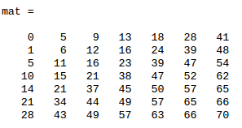

Ans :

(2, 0 ) (0, 1 )

#9

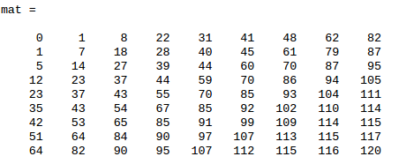

Ans :

(4, 4 ) (3, 5 ) (2, 6 )

#10

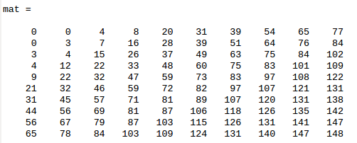

Ans : (5, 8 )